# Evaluating quality and Quality Status

## Evaluating quality

**# Source**: **Chatgpt (GPT-5-Standard) at [8/12/2025]**

**Evaluating quality** means measuring how well something — in this case, software — meets defined standards, expectations, or requirements.

In software, it’s about checking:

1. **Does it work correctly?** (Functionality)
2. **Is it easy to use?** (Usability)
3. **Is it fast and stable?** (Performance & Reliability)
4. **Is it secure?** (Security)
5. **Will it keep working after changes?** (Maintainability)

### How We Evaluate Software Quality

**# Source**: **Chatgpt (GPT-5-Standard) at [8/12/2025]**

We usually follow these steps:

1. **Define quality criteria** – Based on standards (like ISO/IEC 25010) or client requirements.
2. **Measure** – Use tests, metrics, and user feedback. Examples:  
   * Bug count per release
   * Response time under load
   * Percentage of passed test cases
3. **Compare against benchmarks** – Industry standards, competitor performance, or historical data.
4. **Report and decide** – If it meets the target, it’s “good quality”; if not, it needs improvement.

### Why It Matters

**# Source**: **Chatgpt (GPT-5-Standard) at [8/12/2025]**

If we don’t evaluate quality:

* Users may face errors or frustration.
* Companies may face security breaches or financial loss.
* The product may fail in the market.

## Quality Status

### ✅ Definition

**# Source**: **Chatgpt (GPT-5-Standard) at [9/4/2025]**

**Quality Status** is a **measure or indication of the current quality of a software product** at a given point in time.

In simple terms: it tells **how good or reliable the software is right now**, based on testing results, defects found, and coverage achieved.

It is often reported in **test reports** to help stakeholders decide whether the product is ready for release, needs more testing, or requires fixes.

### 🔹 What Determines Quality Status

**# Source**: **Chatgpt (GPT-5-Standard) at [9/4/2025]**

1. **Test Execution Results**
   * Number of test cases passed, failed, or blocked.
2. **Defects Found**
   * Number of critical, major, and minor defects.
   * Severity and impact of defects on the system.
3. **Coverage Metrics**
   * Percentage of requirements, code, or features tested.
   * How much of the high-risk functionality has been covered.
4. **Risk Assessment**
   * Are there unresolved risks that may affect the product?
5. **Compliance with Standards**
   * Does the product meet functional, security, performance, and regulatory requirements?

### 🔹 Example of Quality Status

**# Source**: **Chatgpt (GPT-5-Standard) at [9/4/2025]**

**Project:** Online Banking App

* Test Execution: 95% test cases passed
* Defects: 2 critical, 3 major open
* Coverage: 100% of critical requirements tested
* Risk: Payment module under high load not fully tested

**Quality Status:**

Moderate – core functionality works, but some critical issues remain; not yet ready for production.

### 💡 Key point:

**# Source**: **Chatgpt (GPT-5-Standard) at [9/4/2025]**

Quality Status is **a snapshot of software quality at a given time**, helping decision-makers evaluate **release readiness** and **risk levels**.

### is Quality Status is same Evaluating quality

**# Source**: **Chatgpt (GPT-5-Standard) at [9/4/2025]**

Not exactly — they are related but **not the same**. Let me clarify:

**🔹 Difference Between Quality Status and Evaluating Quality**

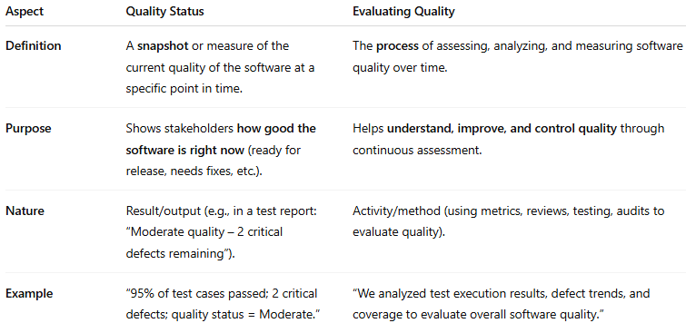

| **Aspect** | **Quality Status** | **Evaluating Quality** |
| --- | --- | --- |
| **Definition** | A **snapshot** or measure of the current quality of the software at a specific point in time. | The **process** of assessing, analyzing, and measuring software quality over time. |
| **Purpose** | Shows stakeholders **how good the software is right now** (ready for release, needs fixes, etc.). | Helps **understand, improve, and control quality** through continuous assessment. |
| **Nature** | Result/output (e.g., in a test report: “Moderate quality – 2 critical defects remaining”). | Activity/method (using metrics, reviews, testing, audits to evaluate quality). |
| **Example** | “95% of test cases passed; 2 critical defects; quality status = Moderate.” | “We analyzed test execution results, defect trends, and coverage to evaluate overall software quality.” |

**💡 Key Point**

* **Evaluating quality** → *what we do*: analysis and assessment.
* **Quality status** → *what we get*: the outcome of that evaluation at a particular time.

Think of it like a **health check**:

* **Evaluating quality** = the doctor examining you, taking tests.
* **Quality status** = the report card saying “Your health is good/moderate/poor.”